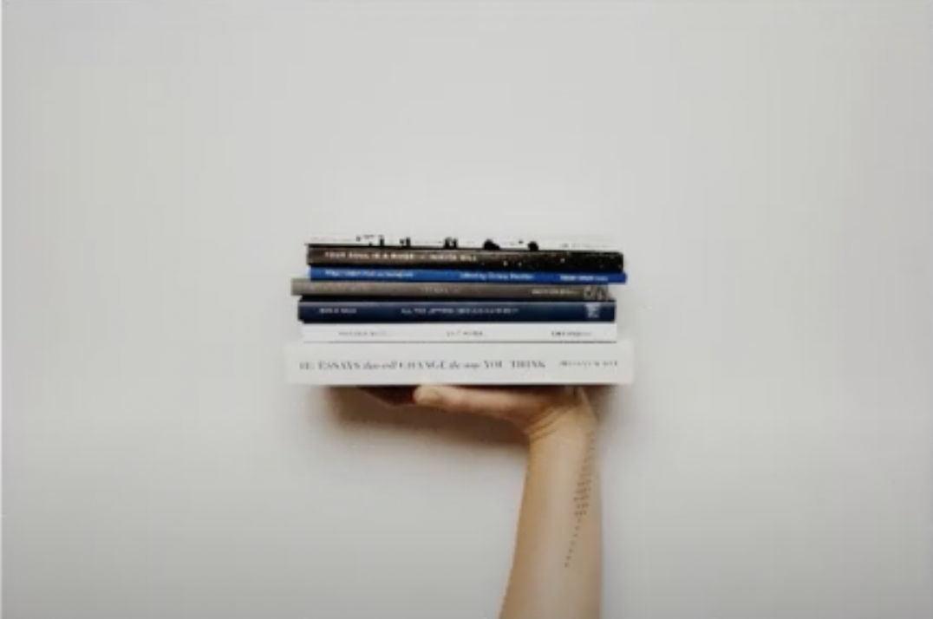

*Below Is the Summer Reading Assignment for the 2023-2024 School Year:*

| **Task:**  **Become an Expert on a Topic of Your Choice!**  Choose a topic, a country, or a person to focus on. (Anything you want to know more about.) Become an expert on that subject by reading/annotating articles, finding relatable books or watching videos. This task will |
| --- |

[**https://youtu.be/evBkuLZFX-4**](https://youtu.be/evBkuLZFX-4)

Subject: ______________________________________________

Requirements:

* Pick a subject that is current (Within the last 5 years)
* Bring in a minimum of 5 **annotated** articles
* Complete the task packet note catcher for **EACH** annotated article

*Examples of a Subject To Become an Expert On:*

***You do not need to use these options!***

* Country (Japan, Argentina, United States)
* Physical vs Digital communication
* Standardized Testing
* Body Image
* Environmental Factors in specific areas
* Insomnia
* Stress
* Mental Health
* Youth Violence
* Technology
* Artificial Intelligence

*The Following Note Catcher Is Set Up Like This…*

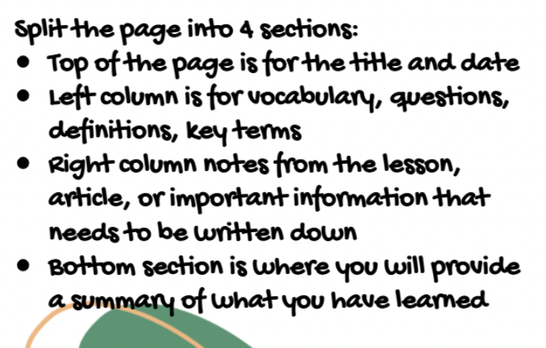

*Example of What a Note Catcher Should Look Like:*

| TITLE & AUTHOR OF ARTICLE:  New York Times: Can Supplements Help You Focus?  By: Dani Blum |
| --- |

| Vocab Words / Questions / Definitions:  **Revolutionary Hack:** life changing short cut  **Cognitive Improvement:** increase in performance on mental abilities including learning, thinking and memory  **Deficient:** low on or lacking  **Q.** How can I know how much of each vitamin and mineral I need for best focus / health ? | Essential Information from Article:   * “Some manufacturers claim certain formulations can sharpen the mind, but experts say the evidence behind that idea is lacking.” |
| --- | --- |

| Summary (5-7 sentences):  This article taught me … |
| --- |

| TITLE & AUTHOR OF ARTICLE: |
| --- |

| Vocab Words / Questions / Definitions: | Essential Information from Article: |
| --- | --- |

| Summary (5-7 sentences): |
| --- |

| TITLE & AUTHOR OF ARTICLE: |
| --- |

| Vocab Words / Questions / Definitions: | Essential Information from Article: |
| --- | --- |

| Summary (5-7 sentences): |
| --- |

| TITLE & AUTHOR OF ARTICLE: |
| --- |

| Vocab Words / Questions / Definitions: | Essential Information from Article: |
| --- | --- |

| Summary (5-7 sentences): |
| --- |

| TITLE & AUTHOR OF ARTICLE: |
| --- |

| Vocab Words / Questions / Definitions: | Essential Information from Article: |
| --- | --- |

| Summary (5-7 sentences): |
| --- |

| TITLE & AUTHOR OF ARTICLE: |
| --- |

| Vocab Words / Questions / Definitions: | Essential Information from Article: |
| --- | --- |

| Summary (5-7 sentences): |
| --- |